2024-25 Alta High School Parking Areas

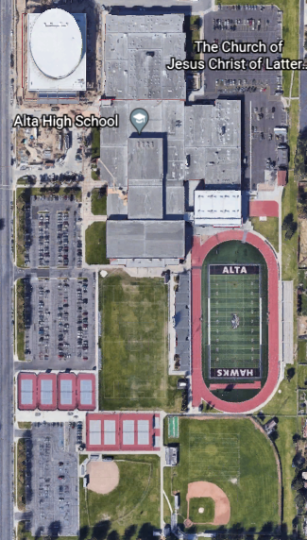  Visitor PAC Lot  Faculty East Lot  Gym & Soccer Field Lots  Drivers Ed Lot | Student Parking Areas (Red)  - Drivers Ed Lot  - Gym & Soccer Field Lots  Faculty Parking Areas (Blue)  - East Lot  Visitor Parking Area (Green)  - PAC Lot  Reserved Areas (Orange)  Areas marked with signage  - North row in Gym Lot  - Student Gov’t and Secretaries in PAC Lot  No Parking Area (Black stripes)  No parking east of the CTE classrooms. Area reserved for deliveries, maintenance and construction vehicles, and CSD Auxiliary Services  Please note  - After 3 PM on Mondays-Thursdays cars parked in the Faculty East Lot and Drivers Ed Lot need to be moved for marching band practice and Drivers Ed instruction  - ADA tags must be visible if parking in ADA parking stalls  - Motorcycle parking is in the Faculty East Lot

