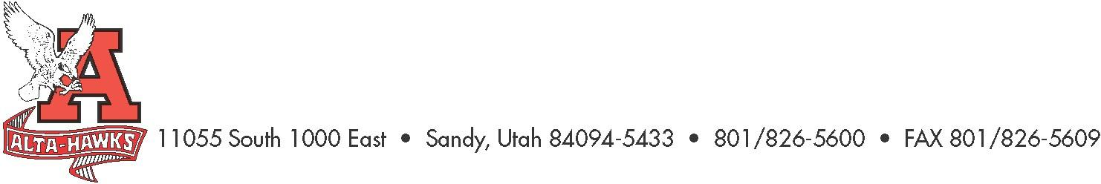
Alta High School

SCC Minutes
April 24th, 2023

In attendance: Kjersti Barlow, Chad VanOrden, Ken Rowley, Shelly Karren, Katie Christensen, Nicole Harman, Paige Haddocks, Zach Scheffner, Jeff Colemere, Navina Forsythe, Tess Hortin, Callie Bjerregaard, Page Checketts, Melissa Gibbs, Katie Atkinson. Erin Black
Not in attendance: Kelly Maksem, Merinda Cutler, Nele Ofisa

- Welcome – Katie Christensen
Called to order: 3:19
- Minutes from the last meeting – Katie Christensen
Motion to Approve: Tess Hortin
Seconded: Nicole Harman

- SBO Update/Report – Paige and Zach
- Graduation is coming up along with senior sunset, senior dinner dance, end of year stomp, and assembly. Things are slowing down, and new SBOs are taking over
- It has been a great and successful year

- PTSA Update – Nicole Harman
- 30 nominations, alta is the only school utah pta.org teacher walk of fame
- Staff appreciation is first week of May. Planning a waffle dessert bar, nacho bar, and luncheon. Still in need of monetary donations for gift cards for teachers
- State convention is in three weeks
- Last PTSA meeting will be on the May 9, volunteer luncheon
- All Resilient Hawks will be awarded a check no matter which college they attend, or if they don’t attend college

- Counseling Corner – Mrs. Bjerregaard
- Deadlines for seniors is coming up quickly
- Caps and gowns will be passed out on Thursday, and will be held in main office if they are not cleared
- Senior assembly will be on Tuesday. Admin is running the meeting which is mandatory for all seniors
- May 8 is the principal’s reception - resilient hawk, 3.9+, athletes of the year, sterling scholars will be recognized
- May 17, breakfast in the commons during advisory for seniors earning Hawk Medallions, Step 2 the U, Seal of Biliteracy, Advanced and Honors diplomas
- The Honors and Advanced diplomas are being reviewed by the board of education. Changes are likely. Those diplomas used to be aligned with the regents scholarship, but there is no regents scholarship anymore. It will not match any scholarships and may involve attendance
- We will hold summer school at Alta again this year. It will be the first 3 weeks in June. Summer school is free. Students will do packets with a teacher in that area. Math will not be a packet but will be taught by a teacher who will present the material. Students can sign up now online for summer school. Grades will only be a pass/fail. They will have to choose a different avenue for credit recovery

- Aspire Testing – Shelly Karren
- Ken announced that Shelly has been transferred to Indian Hills and will not be here next year
- Testing is important. It really does help to know the metrics. State requires a 95% testing rate. We are making progress on that number
- AP testing is coming up in May. It’s an exciting time for students (and teachers) who have been working all year in AP classes
- We have seen decline in enrollment over the last few years in our advanced placement classes, but we are starting to see those numbers increase again
- May 12 is senior accountability day
- Testing signifies the end of the year so it is an exciting time for all students

- Review current plan spending – Mr. Rowley
- We anticipate having only $5,000-$8,000 left in the Land Trust and TSSA accounts
- Graduation Update
  - Thursday, May 25th 10:00am Huntsman Center
- Getting ready and finishing strong. Senior assembly is to remind students who they represent, themselves, their families, the school, etc.

- Construction/Renovation Update – Mr. Rowley
  - Trophy Cases (Begin end of May – 4 week project)
This will begin two weeks after school is out
  - Restrooms (Demolition 90% complete – finish by early November)
Restrooms are 100% demolished. New footings will be poured soon

  - Band Room. (Begin end +- of May – 1 year approximately)
  - Dance Room (Begin end +- of May – 1 year approximately)
- The baseball field is done and in use
- The softball field is still under construction. Weather has been hard. The outfield is a hazard to players. Construction has run into problems such as a broken sewer pipe. Next year more effort will be put into getting the fields ready for play earlier. Softball will have no home games this year

- Thanks and appreciation to SCC members – Mr. Rowley
- We are grateful for the work of the committee and the money that has been approved for student programs
- We are also grateful for Shelly and we will miss her efforts tremendously

- Other Items
Motion to Adjourn: Jeff Colemere
Seconded: Nicole Harman
Meeting Adjourned: 3:49

Next Meeting:
Monday, September 25th, 2023, 3:15 pm

