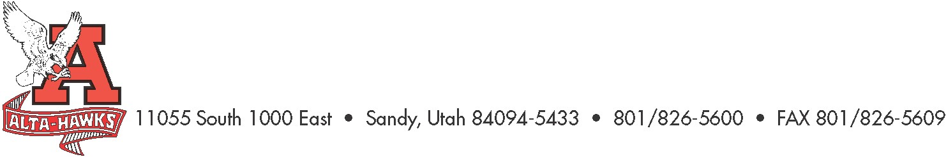
Alta High School

SCC Agenda
February 26th, 2024 - 3:15pm

- Welcome – Katie Christensen
- Approval of Minutes
- SBO Update/Report – Mrs. Louder & SBO’s
- PTSA Update – Nicole Harman
- Counseling Corner – Mrs. Bjerregaard
- TSSP & Trust Land Goals 1st Draft – Mr. Crockett
  - Review of Goals for 2024 – 2025 Plan

Next Meeting:
Monday, March 25th, 2024, 3:15 pm

