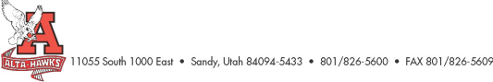Alta High School
SCC Agenda
January 22nd, 2024
- Welcome – Katie Christensen
- Minutes from last meeting - Katie Christensen (3 mins)
- SBO Update/Report SBO’s (5 mins)
- PTSA Update – Nicole Harman (5 mins)
- Counseling Corner – Mrs. Bjerregaard (5 mins)
- Update on current plan (23-24) – Mr. Crockett (30 mins)
  - Goals, Action Items, Data
  - Check & Connect
  - Hawk Watch
- Graduation 23-24 – Mr. Rowley (3 mins)
  - Huntsman Center U of U – Wednesday, May 29th 10:00 am
- Teacher of the Year Nominations – Mr. Rowley (5 mins)
  - January 5th – February 2nd (Nomination window open)
    - https://www.canyonsdistrict.org/nominate-teacheroftheyear/
- Letter from Governor Cox – Cellphones in classroom
- Other Items
Next Meeting: Monday, February 26th, 2024 (3:15 pm)

