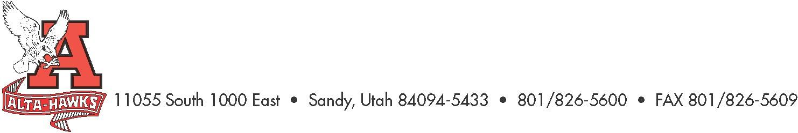
Alta High School

SCC Agenda
November 27th, 2023

- Welcome – Katie Christensen (3 mins)

- Approval of Minutes – Katie Christensen (5 mins)

- SBO Update/Report – Mrs. Louder & SBO’s (8 mins)
  - Alta Make-A-Wish Fundraiser

- PTSA Update – Nicole Harman (8 mins)

- Counseling Corner – Mrs. Bjerregaard (8 mins)
  - PCCR’s (Plan for College and Career Readiness)

- Vote on Digital Citizenship and School Safety Plans as explained in last meeting.

- Review of schoolwide goals, BLT report how goals are being implemented in classrooms – Kory Crockett (10 mins)

- Other Items

Next Meeting:
January 22nd, 2024 - 3:15 pm Hawk Gallery

