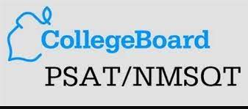

2022 PSAT Information

The Preliminary SAT/National Merit Scholarship Qualifying Test is a great tool for students considering college. The PSAT/NMSQT measures critical reading skills, math problem-solving skills and writing skills. Alta High School recommends that students take the PSAT/NMSQT in order to receive feedback about strengths and weaknesses, enter the competition for National Merit Scholar scholarships (11th graders) and to help prepare for the SAT.
The 2023 PSAT will be administered on Wednesday, October 25th. Students participating in this exam will be excused from their morning classes.
For the 2023 PSAT/NMSQT, students at Alta High School will be registering online. This registration will take a few minutes and can be completed from any computer with internet access.
Online Exam registration will begin in September. Please check back then for more information on how to register.
Please note that the PSAT test will be given in digital format this year for the first time at Alta. College Board no longer allows paper testing of the PSAT NMSQT.
Please contact Jodene Jensen, jodene.jensen@canyonsdistrict.org , if you have any questions.

