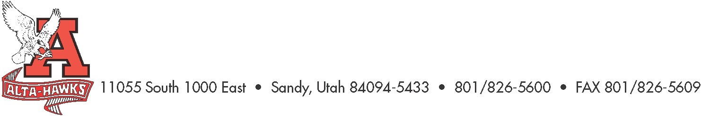

Alta High School

SCC Agenda
February 28th, 2023 - 3:15pm

- Welcome – Katie Christensen
- Approval of Minutes
- SBO Update/Report – Mrs. Louder & SBO’s
- PTSA Update – Nicole Harman
- Counseling Corner – Mrs. Bjerregaard
- TSSP & Trust Land Goals Rough Draft – Ms. Karren
  - Review of Goals for 2023 – 2024 Plan
- Student Activities Update – Shelly Karren

Next Meeting:
Monday, March 27th, 2023, 3:15 pm

