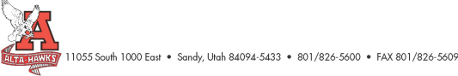Alta High School
SCC Agenda
January 23rd, 2023
- Welcome – Katie Christensen
- Minutes from last meeting - Katie Christensen (3 mins)
- Council members information (pass paper around and check accuracy)
- SBO Update/Report Shaley Louder & SBO’s (5 mins)
- PTSA Update – Nicole Harman (5 mins)
- Counseling Corner – Mrs. Bjerregaard (5 mins)
- Update on data requests from last meeting – Ms. Karren (30 mins)
  - Attendance
  - Check & Connect
  - Hawk Watch
  - Early Warning System
  - Discipline
- Graduation 22-23 – Mr. Rowley (5 mins)
  - Huntsman Center U of U – Thursday, May 25th 10:00 am
- Teacher of the Year Nominations – Mr. Rowley (5 mins)
  - https://www.canyonsdistrict.org/general-news/csd-begins-taking-nominations-for-2023-teacher-of-the-year/
- 23-24 Land Trust Plan progress – Mr. Rowley (5 mins)
- Other Items
Next Meeting: Monday, February 27th, 2023 (3:15 pm)

