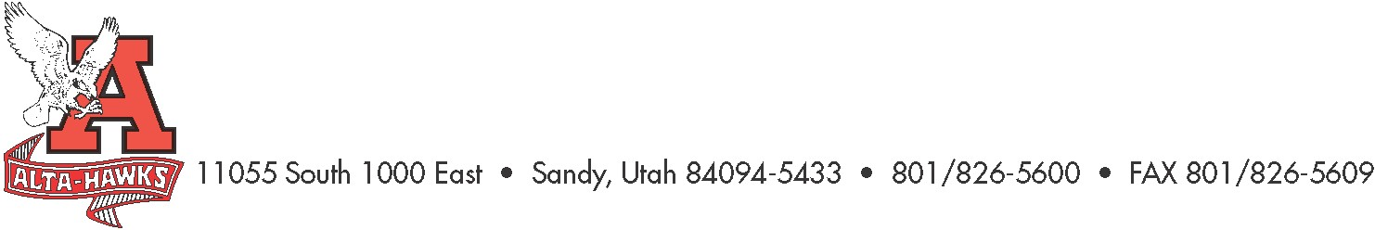
Alta High School

SCC Agenda
November 28th, 2022

- Welcome – Katie Christensen (3 mins)
- Minutes from last meeting – Katie Christensen (5 mins)
- SBO Update/Report – Mrs. Louder & SBO’s (8 mins)
  - Alta Make-A-Wish Fundraiser
- PTSA Update – Nicole Harman (8 mins)
- Counseling Corner – Mrs. Bjerregaard (8 mins)
  - Junior PCCR’s (Plan for College and Career Readiness)
- Accept Digital Citizenship and School Safety Plans as explained in last meeting.
- Report on BLT meeting (focus on goals) – Shelly Karren (8 mins)
- Trust Land Year to Date Report – Mr. Rowley (10 mins)
- Other Items

Next Meeting:
January 23rd, 2023 - 3:15 pm Hawk Gallery

