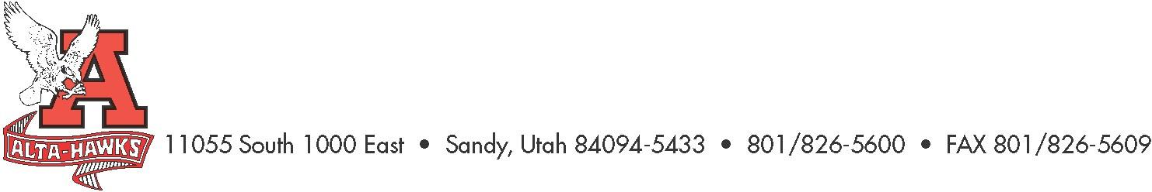
Alta High School

SCC Agenda
October 24th, 2022
3:15pm – 4:30pm
Alta Field House

- Welcome – Katie Christensen
- SBO Update/Report – Mrs. Louder & SBO’s (5 mins)
- MLL focus - Mrs. Jamie Workman (Instructional Coach) (7 mins)
- PTSA Update – Nicole Harman (7 mins)
- Counseling Corner – Mrs. Bjerregaard (7 mins)
- Digital Citizenship – Mrs. Amanda Scott (Librarian) (10 mins)
  - Plan to be shared for input and feedback
  - You can access the CSD Digital Citizenship plan and video by going to the following website: https://www.canyonsdistrict.org/scc-digital-citizenship/
- School Safety Plan - Mr. Jared Tucker (10 mins)
  - Safety priorities at AHS.
- Alta Enrollment Numbers – Mr. Rowley (5 mins)
  - October 1st count & FTE/Staffing
- School Overall Performance Grade from USOE - Ken (10 mins)
- Other Items

Next Meeting:
November 28th, 2022
Please have any agenda items to to Katie Christensen by November 19th

