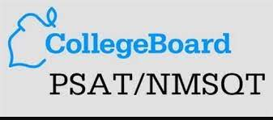

2022 PSAT Information

The Preliminary SAT/National Merit Scholarship Qualifying Test is a great tool for students considering college. The PSAT/NMSQT measures critical reading skills, math problem-solving skills and writing skills. Alta High School recommends that students take the PSAT/NMSQT in order to receive feedback about strengths and weaknesses, enter the competition for National Merit Scholar scholarships (11th graders) and to help prepare for the SAT.
The 2022 PSAT will be administered on Wednesday, October 12th. Students participating in this exam will be excused from their morning classes.
For the 2022 PSAT/NMSQT, students at Alta High School will be registering online. This registration will take a few minutes and can be completed from any computer with internet access.
Online Exam registration will begin on Mon, Sep 19, 2022 at 8:00 AM and end on Fri, Oct 7, 2022 at 10:00 PM. In order to register, students should click on the link provided on the school website or visit www.TotalRegistration.net/PSAT/450402 . To complete registration, students must answer all of the required questions. Registration is not complete until students have printed the pdf of the confirmation page that is provided at the end.
*There are a limited number of tests available, so register before they sell out!*
Alta High School is excited to offer families the convenience of paying exam fees online at the time of registration. Please be sure to have a debit or credit card available before beginning registration. Paying online is a great way to make sure that payment has been made while avoiding mailing your payment.
Here are the important dates for the registration process:
- Mon, Sep 19, 2022 at 8:00 AM - Registration Begins
- Thr, Oct 6, 2022 at 10:00 PM - Registrations and payments after this date will incur a $5 late fee .
- Fri, Oct 7, 2022 at 10:00 PM - Registration Ends
- Wed, October 12, 2022 – PSAT Test

Please contact Jodene Jensen, jodene.jensen@canyonsdistrict.org , if you have any questions.

