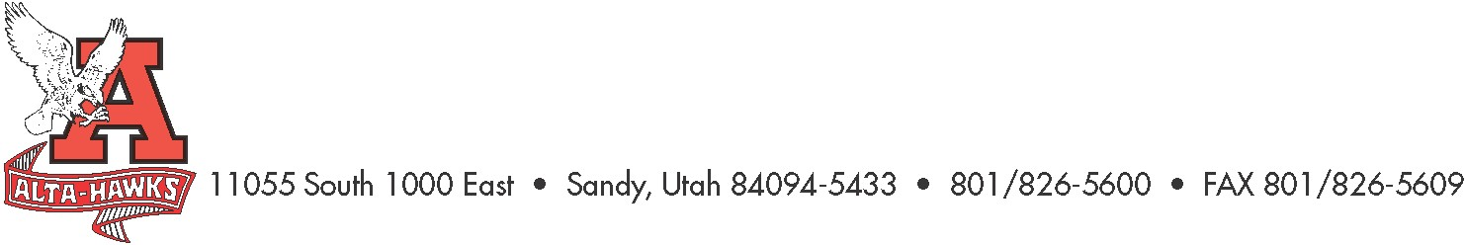
Alta High School

SCC Agenda
September 19, 2022

- Welcome – Katie Christensen
  - Introductions
- Election of SCC Vice Chair – Katie Christensen
- SCC Expectations and Responsibilities – Katie Christensen
- SBO Update/Report – Mrs. Louder & SBO’s
- PTSA Update – Nicole Harman
- Counseling Corner – Mrs. Bjerregaard
- Attendance Policy – Ms. Karren
- Advisory & Intervention – Ms. Karren
- ACT data – Ms. Karren
- Advanced Placement (AP) Data – Ms. Karren
- Professional Development Calendar – Mr. Rowley
- Early out Friday’s / PLC’s – Mr. Rowley
- Step2TheU Update – Mr. Rowley
  - 7th Summer Cohort - 2023
- Other Items

Next Meeting:
October 24th, 2022 (Digital Citizenship Plan)

